Topology
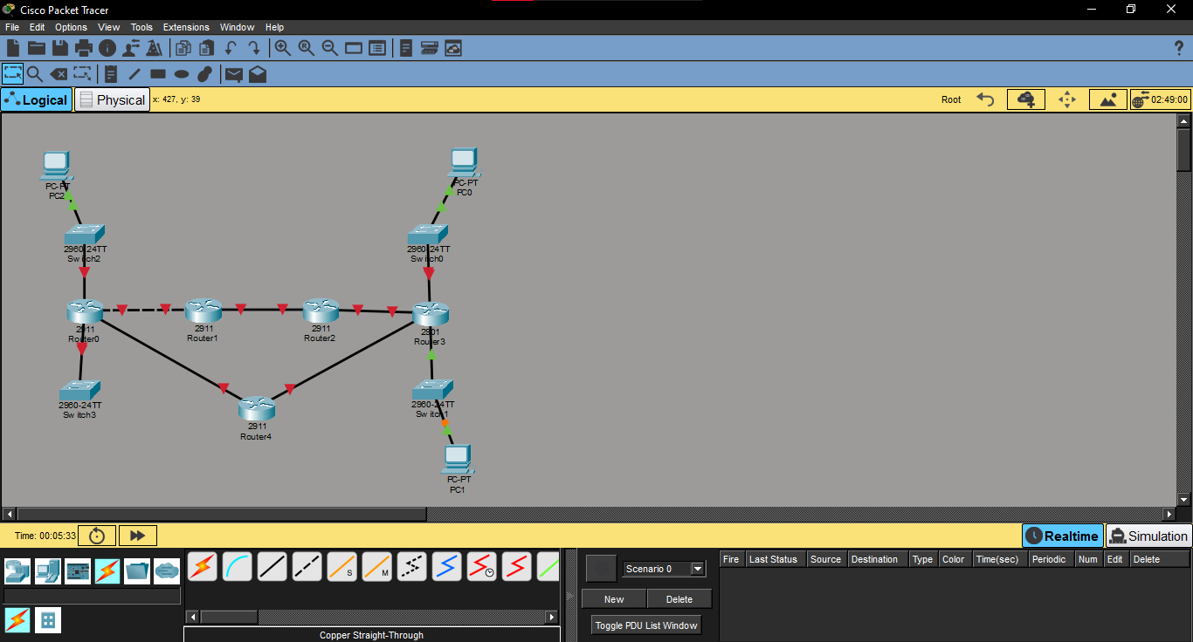

Task74: RIPv1 Configuration
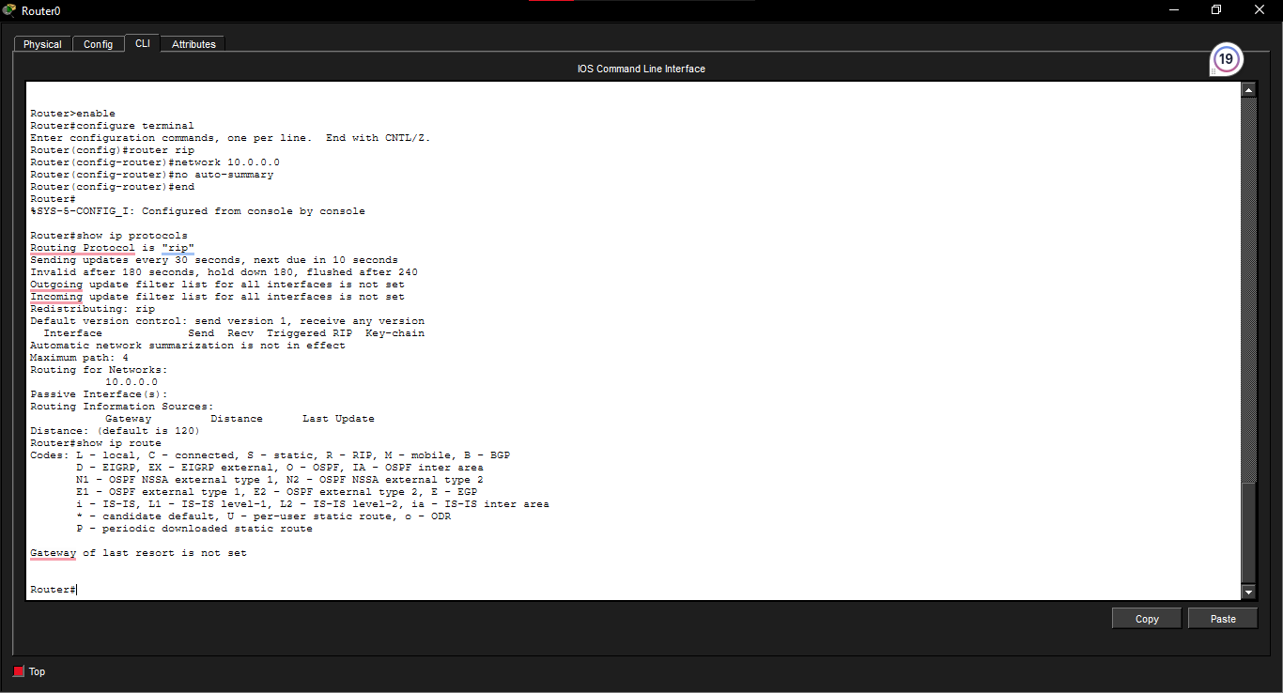

Reflection question
84. RIPv1 uses broadcast traffic to send routing updates to all devices on the network. RIPv2 uses multicast traffic to send updates to the address 224.0.0.9, which reduces unnecessary network traffic
85. There are two routes because RIPv1 and RIPv2 are both using RIP to learn routes through different paths. The router can learn the same network from two different neighbouring routers.
86. No RIP routes are no longer preferred in R1s routing table. OSPF has an administrative distance of 110 while RIP has 120. OSPF is therefore preferred leaving one best route, to the network.
87. The routing table can display an outgoing interface and a new metric because OSPF finds the best path again after a link goes down. The route switches to another path if there is one.
88. The RIP database holds details about routes that are learned from routers. The OSPF database contains link-state data about the network’s routers and the connections, between them. OSPF uses this data to create a picture of the network and find the shortest paths.

